Shammah Thao

EEE 174 - CpE 185 Lab Section #2

Monday & Wednesday

Lab 5 – Area of Interests

Dahlquist

Introduction:

For this lab, I connected this part to what I needed to do for the final project. For the final project, we were planning on building a weather station logger. It basically used the hardware Sense hat to collect data surrounding it. It would display things that we want such as temperature, pressure, its orientation and so on. For me, I’m working on magnetometer and barometric pressure so what I did was put them all into one code and demo it for my lab 5.

Due to not having the physical device on hand, I used an online simulator from the website trinket.io

It has its own online sense hat that has the features that I needed for the code.

DEMO:

For my code I made it take in the pressure from the sense hat, along its its orienation. The code

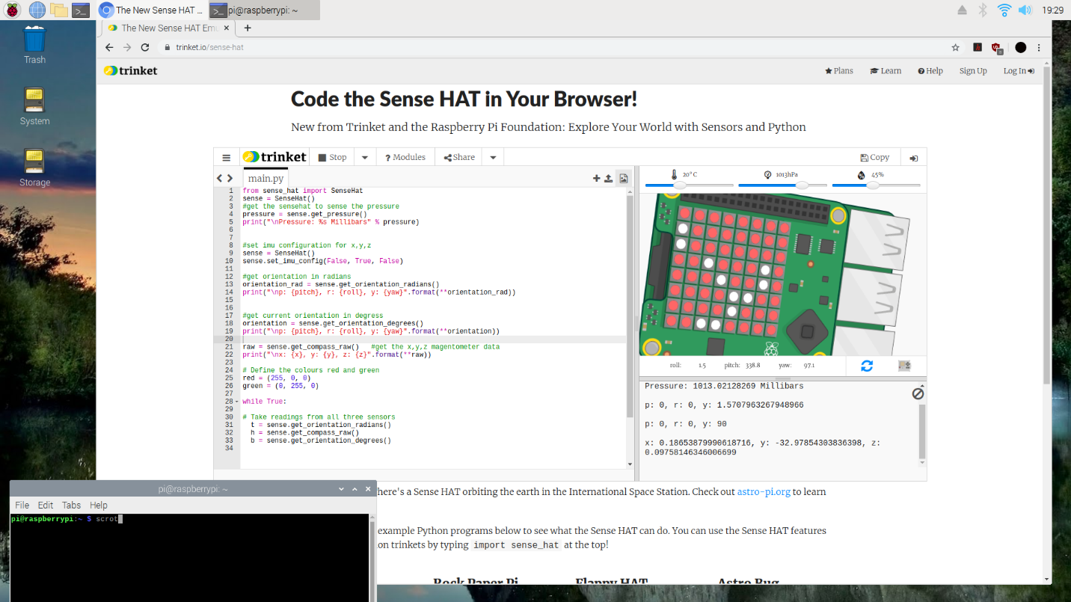

The codes are then outputed on the display board. Showing the thing that I asked for which are the pressure, its oriention in radians, its orientation in degrees and along with the x,y and z coorindates.



Adding in a couple of line of code made me be able to print out the information onto the sense hat RGB.



Conclusion:

In conclusion, this is just the first part of what I need to do for the final project, just by doing this and showing what I have it complete so far. The final project is going to be a more complete version of code that would involve different code integrated together. Although this doesn’t have the actual physical part yet, the final project would have an actual part included in there so it is more complete.